//DEEPIKA SHARMA -124959
ASSIGNMENT -3.2 SET OPERATORS

3.1.1.Get the details of all products irrespective of the fact whether they are in previous set or current set.
SELECT pid,name,unit,price ,stock
from previous_products
union
SELECT pid,name,unit,price ,stock
from current_products
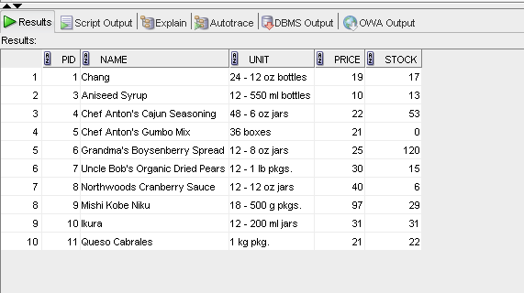
3.2.1 Get the details of all products along with the repetition of those that were present both in the previous and current sets.
SELECT pid,name,unit,price ,stock
from previous_products
union ALL
SELECT pid,name,unit,price ,stock
from current_products
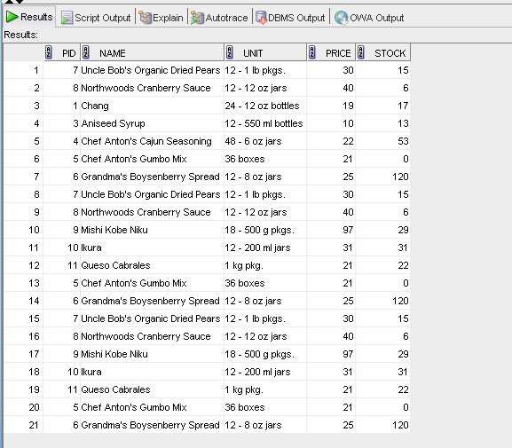

3.2.3 Get the details of only those products which were present in the previous set and are still continuing.

SELECT pid,name,unit,price ,stock
from previous_products
INTERSECT
SELECT pid,name,unit,price ,stock
from current_products
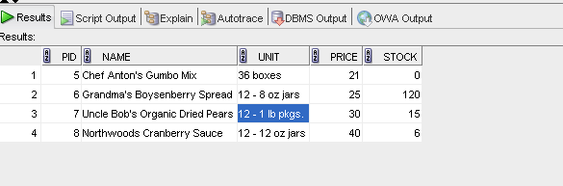

3.2.4. Get the details of all obsolete products (no longer continued).
SELECT pid,name,unit,price ,stock
from previous_products
MINUS
SELECT pid,name,unit,price ,stock
from current_products
